Scenario:

Windows PPTP client---(lan)DFL210---(wan)PPTP server

1. Create a NAT rule for PPTP

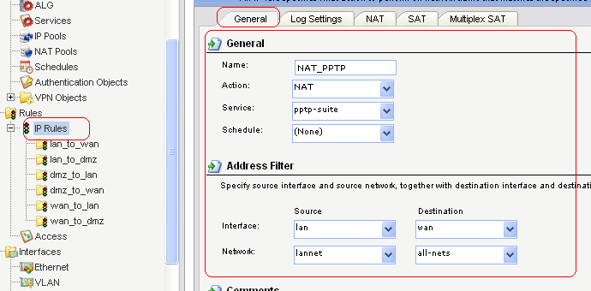2. Pass the PPTP packet through the unit without prrocess
