How to configure traffic management for Quality of Service assurance

Detail for this scenario:
- Internet upstream/downstream commit rate is 2000Kbps/2000Kbps.
- SMTP protocol with Bi-direction: The bandwidth is guaranteed to 800Kbps and the maximum
bandwidth limit is 1600Kbps.
- HTTP/HTTPS protocol with Bi-direction: The bandwidth is guaranteed to 600Kbps and the maximum bandwidth limit is 1200Kbps.
- FTP protocol with Bi-direction: The bandwidth is guaranteed to 400Kbps and the maximum bandwidth limit is 800Kbps.
- Other protocols with Bi-direction: The bandwidth will NOT be guaranteed and limited. It can burst its traffic to use all available bandwidth if SMTP/HTTP/HTTPS/FTP is not full traffic load.
- SMTP is first priority; precedence will be assigned to 7.
- HTTP/HTTPS is second priority; the precedence will be assigned to 5.
- FTP is third priority; the precedence will be assigned to 3.

[Topology]:
PC(192.168.1.X)-----(192.168.1.1)DFL-210-----PPPoE(100M)

[Configuration]: (Firmware 2.26.02.05)
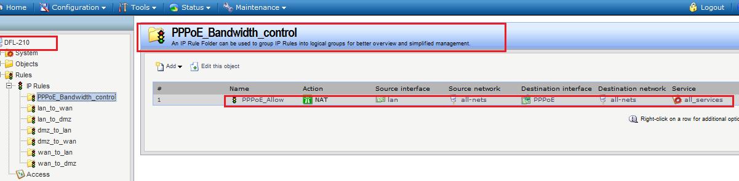
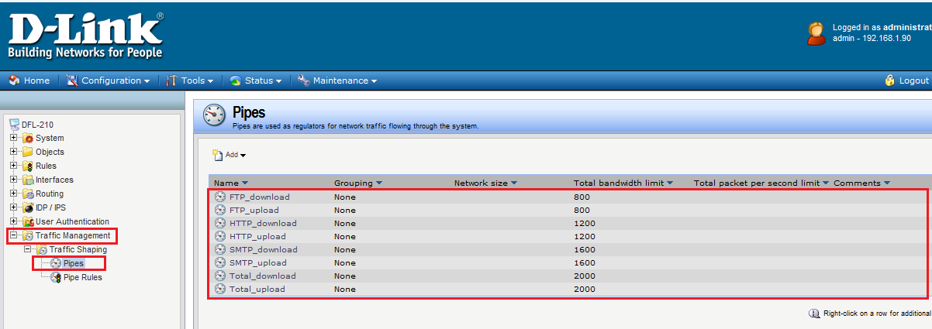
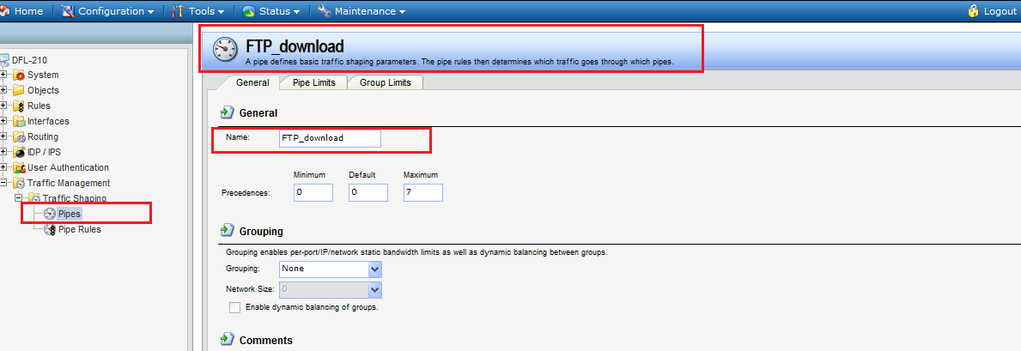
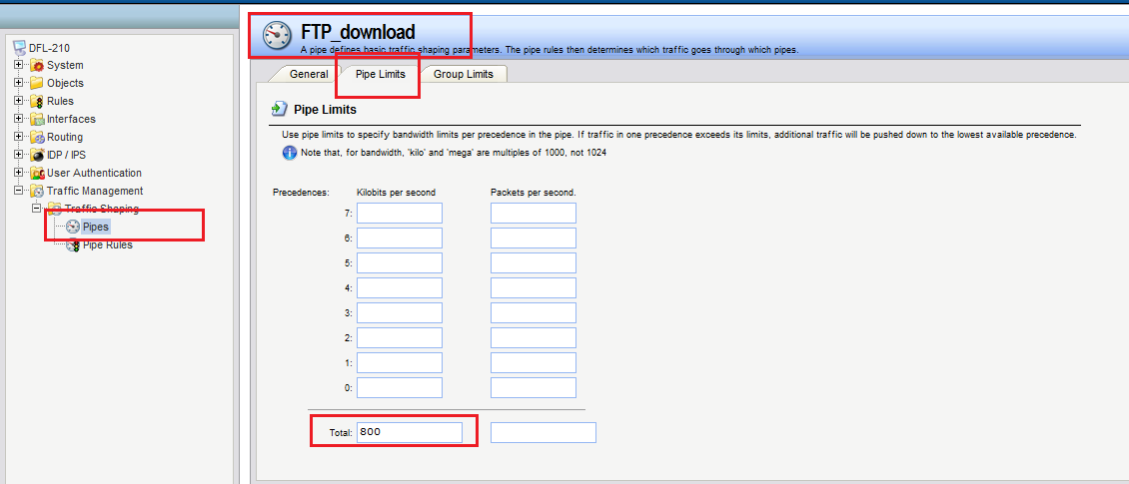
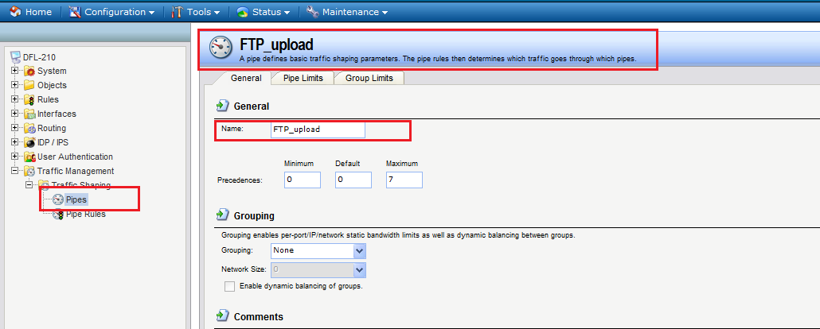
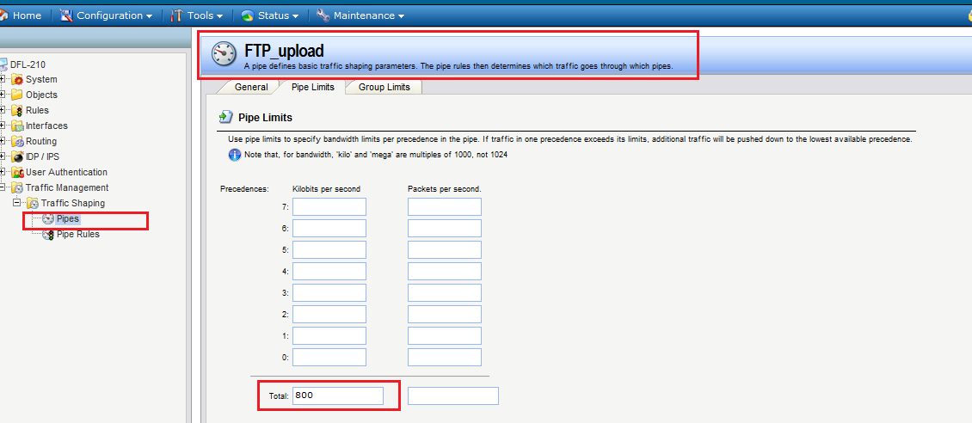
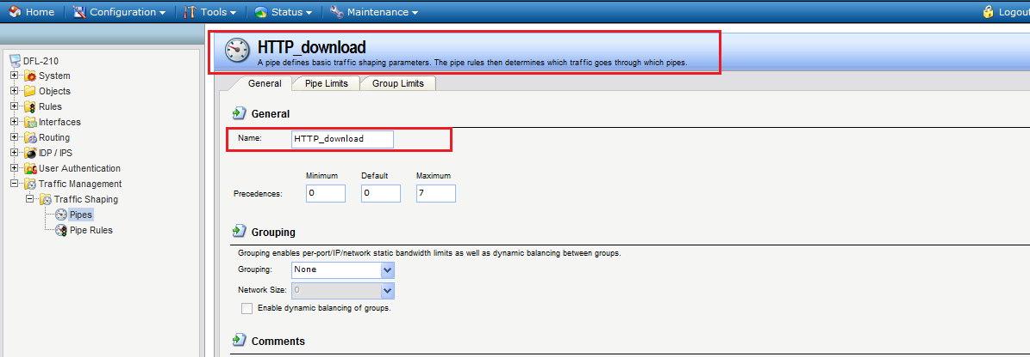
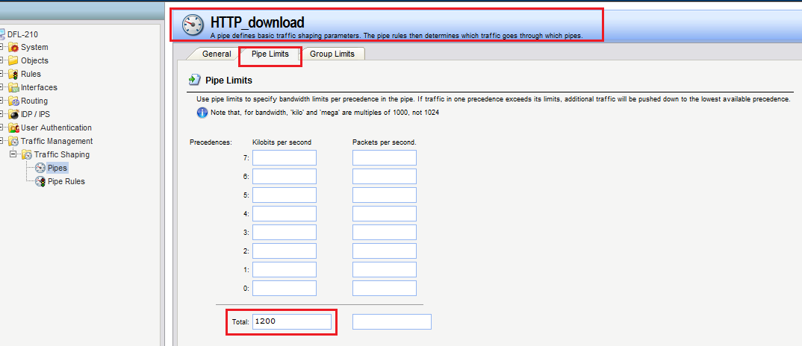
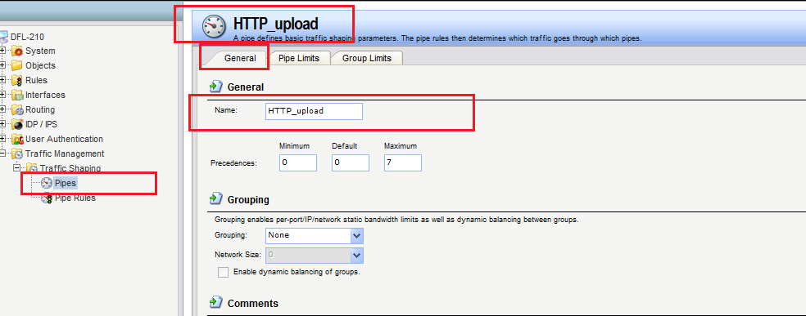
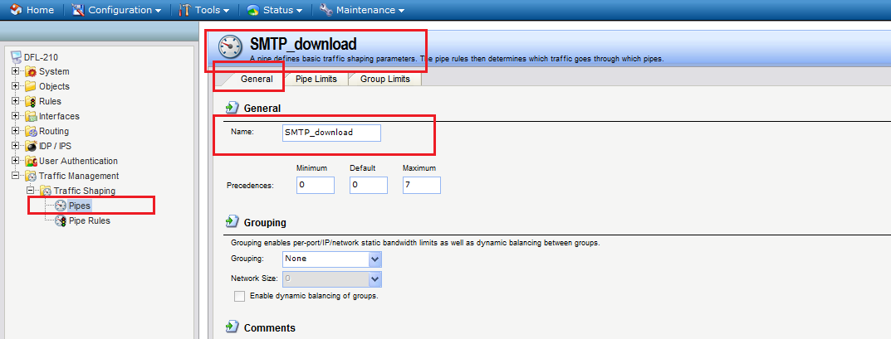
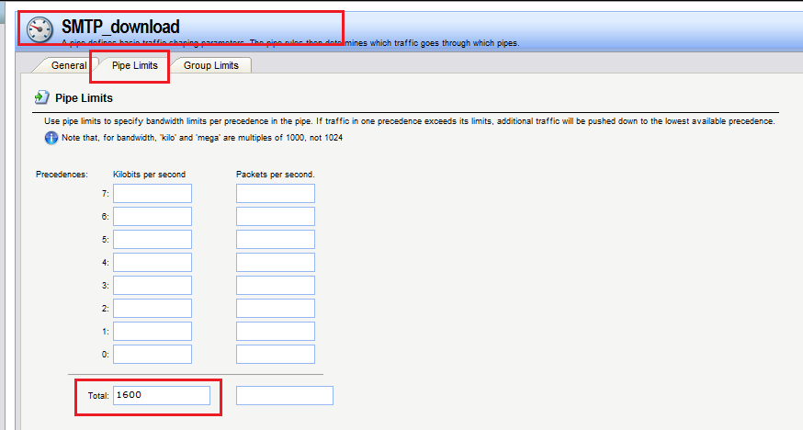
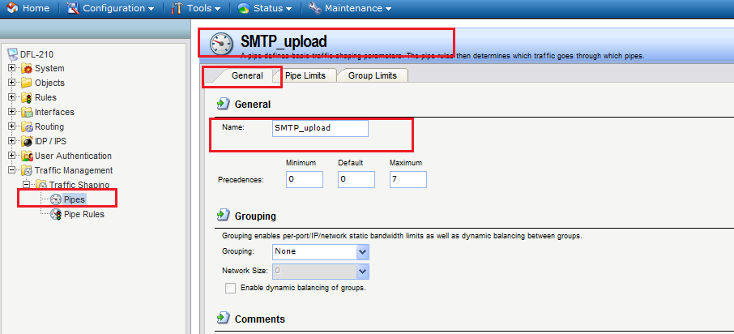
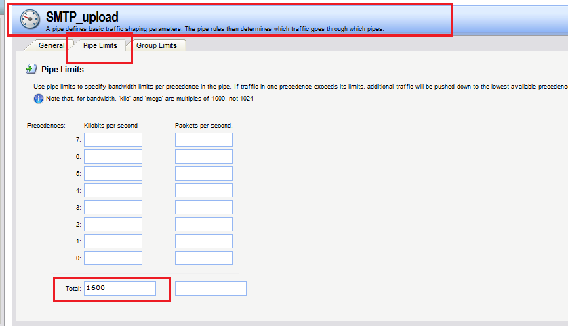
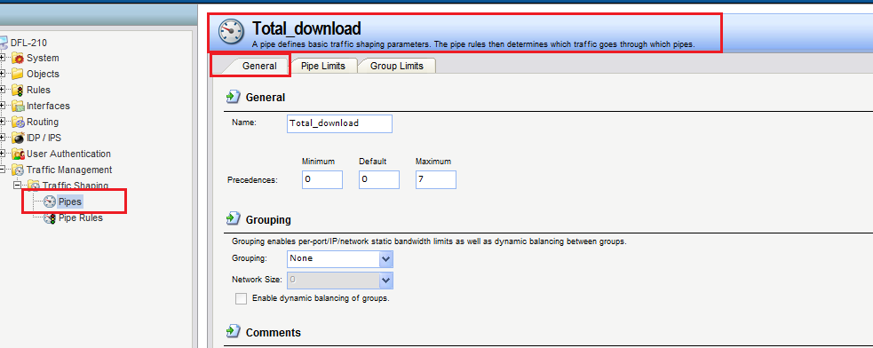
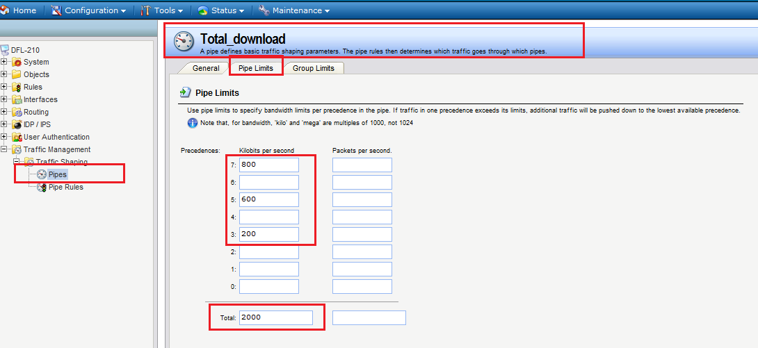
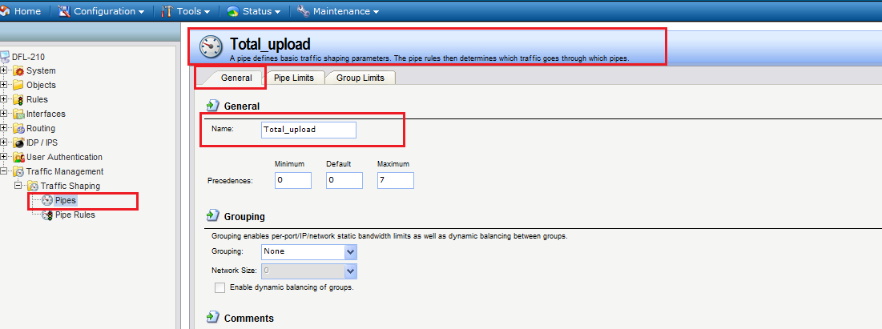
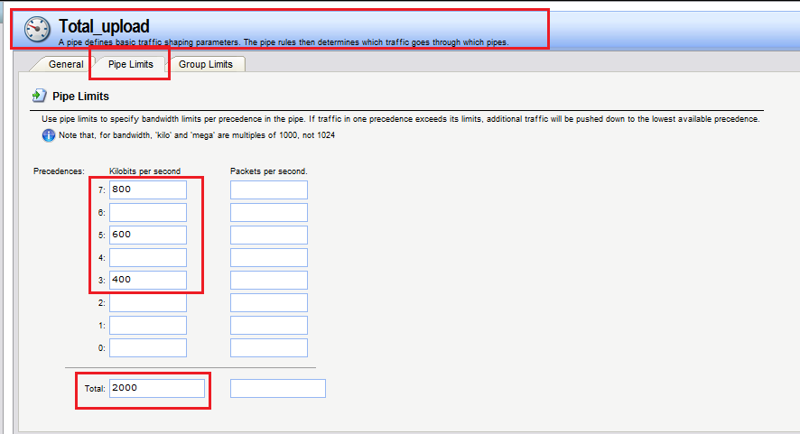
[Testing Result]:
- We use the PC to download the BT and make sure the total bandwidth should be limited below 2Mbps.
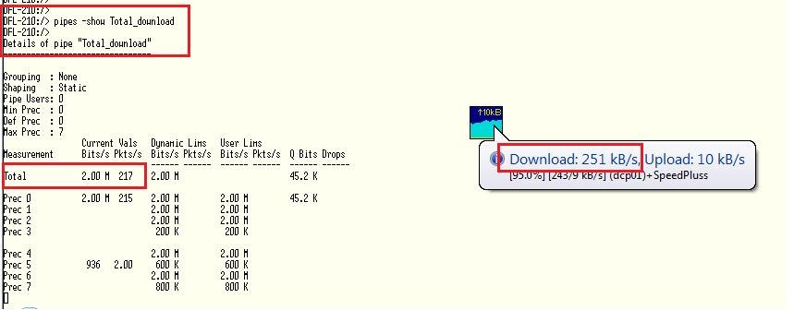
251KB*8=2008KB=2M

