How to set up a PPtP server on your DFL-210
Firstly you will need to upgrade your Firewall’s firmware before you continue with the setup. Firmware can be downloaded here → ftp://ftp.dlinktech.co.za
Log into your firewall.
To log in, open your browser and type the IP address of the firewall in the address bar and press “Enter”.
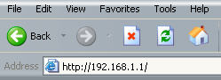
This will take you to the Login screen. Use “admin” as username and “admin” as password.
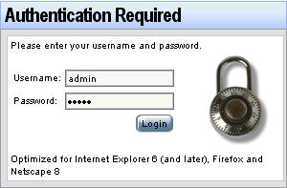
Now you are logged into your firewall.
Upgrading the firmware.
Click on Maintenance and then upgrade.
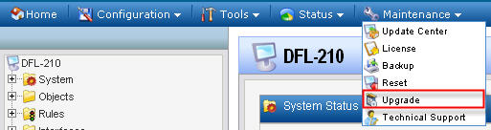
Click on the Browse button (1) to browse to the firmware you downloaded and saved on your computer, select it and click on Upload firmware (2).
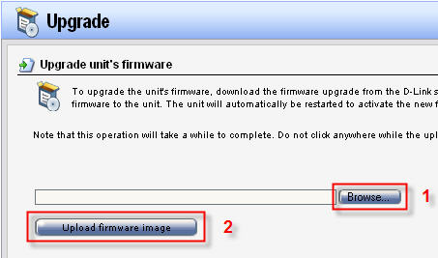
You have now upgraded your firmware.
Now you have factory reset your firewall by clicking Maintenance and Reset.
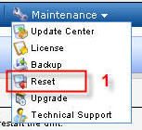
Choose the 1st option under Reset to factory defaults and click reset to factory defaults.
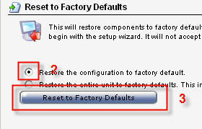
Log into your firewall again and then run the setup wizard and click next till you get to the WAN interface settings. Choose Wan in the drop-down menu and then next.
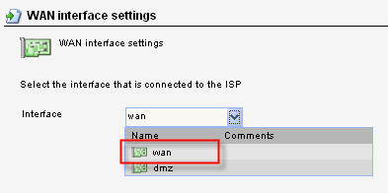
Choose the PPPoE option and click next
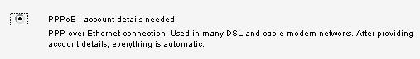
Fill in you username and password as per your ISP.
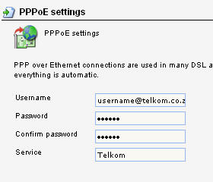
Click on activate when done.
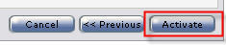
You are done with your Internet connection setup.
Now we need to set up your DDNS account. Click System → Misc. clients → Add and choose DynDnsClientDyndnsOrg. (Note that this firewall will not accept an account from no-ip.com)
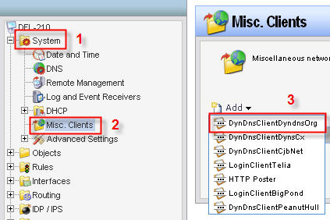
Fill in your hostname, username and password for you DDNS account and click OK.
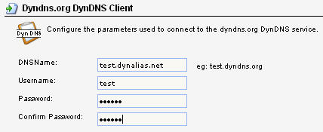
To set up your DNS settings click on System and DNS and choose wan_dns1 for your Primary server and wan_dns2 for your secondary server.
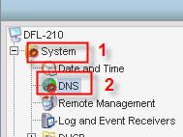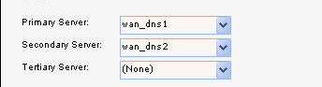
Now we need to set up a rule to allow remote users to ping the WAN side of the firewall. Click on Rules → IP Rules → Add → IP Rule.
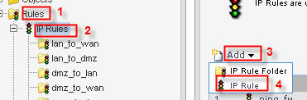
Enter the following settings exactly as in picture below and click on OK.
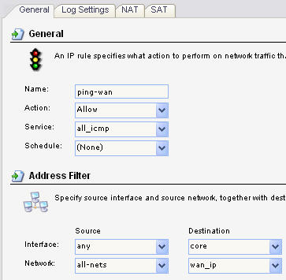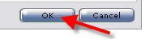
Now we need to create a PPtP server IP address. To do this click → Objects → Address Book → InterfaceAddresses → Add → IP address.
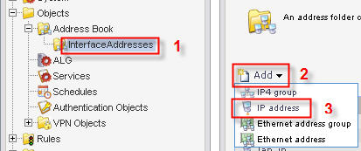
Enter settings exactly as in picture below. (Note that PPtP-server-IP needs to be different than the IP address of the firewall which is 192.168.1.1.)
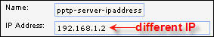
Now we need to set up an IP address range - this is the IP addresses that will be allocated to each authenticated remote user.
Enter settings exactly as in picture below. (Note that PPtP-server-IP range also needs to be different than the IP range of the network behind the firewall which is 192.168.1.x)
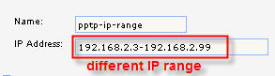
The InterfaceAddresses page should look something like this now.
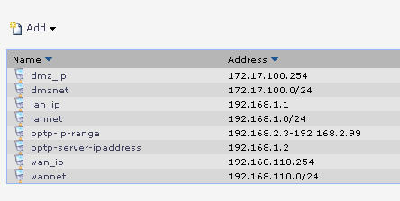
Now we need to create a Local database for PPtP authentication. Click User authentication → Local User databases → Add → Local user database.
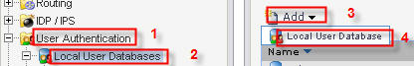
Name the Local User Database “pptp-server”.
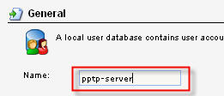
Let’s create some users on the pptp-server database. Click User authentication → Local User databases → pptp server → Add → User. Fill in the desired username and password. Repeat this step if more than one user are needed.
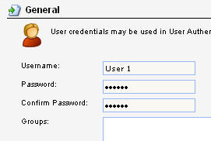
To create the PPTP tunnel click Interfaces → PPTP/L2TP Servers → Add → PPTP/L2TP Server.
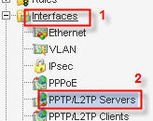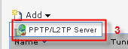

Enter settings under “General” exactly as in picture below.
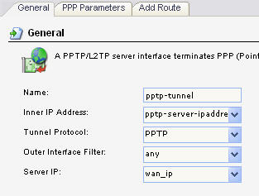
Under “PPP Parameters” select “use authentication rules” and in the “IP Pool” drop-down menu choose “pptp-ip-range”

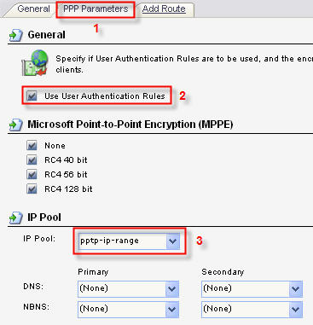

Now we need to create User Authentication rules for the PPtP tunnel. Click User Authentication → User Authentication Rules → Add → UserAuthRule.
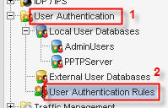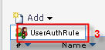
Enter settings under “General”, “Log Settings” and “Authentication Options” exactly as in pictures below.
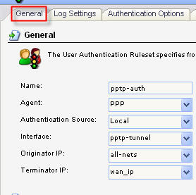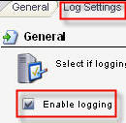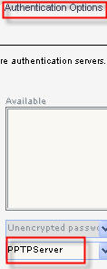

Now we will create IP Rules for the PPTP tunnel. Click on Rules → IP Rules → Add → IP Rule.
Enter settings under “general” and “Log settings” exactly as in the picture below.
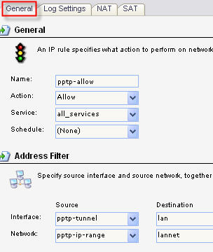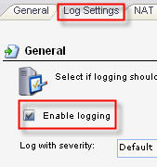
Now you “save and activate”.
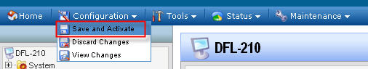

Now your firewall is set up with a PPtP server to allow remote users onto your network.

