How to Install and Configure NetDefend Plug-in

- Configure DFL series.
Under System > Remote Management > Add > SNMP Management
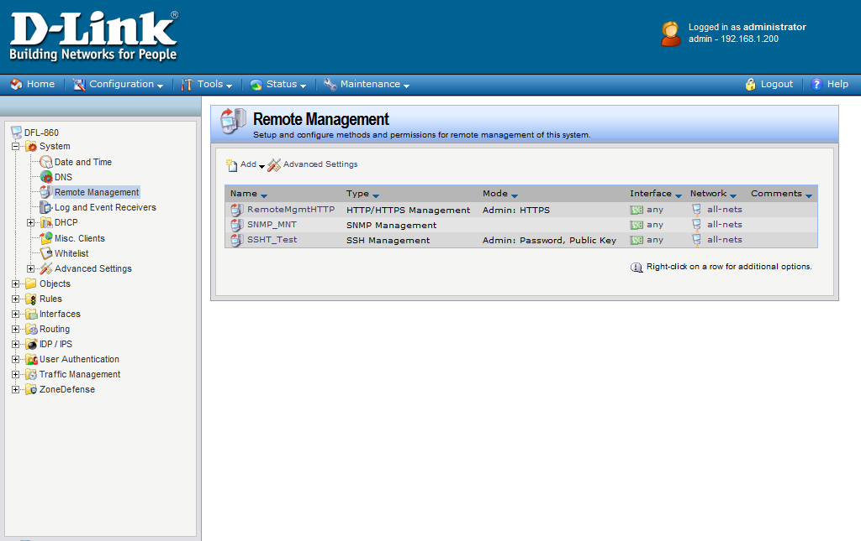

Please pay attention on
- Community Name:
This should be identical with the setting in D-View. By default, it should be named as public
- Access Filter:
- Interface: define which interface SNMP Trap would send out
- Network: define which network SNMP Trap would send out
For simplification purpose, you could use any for Interface, and all-nets for Network.

<Notices!!>
The above setting is not safe, just for concept or feature proven only.

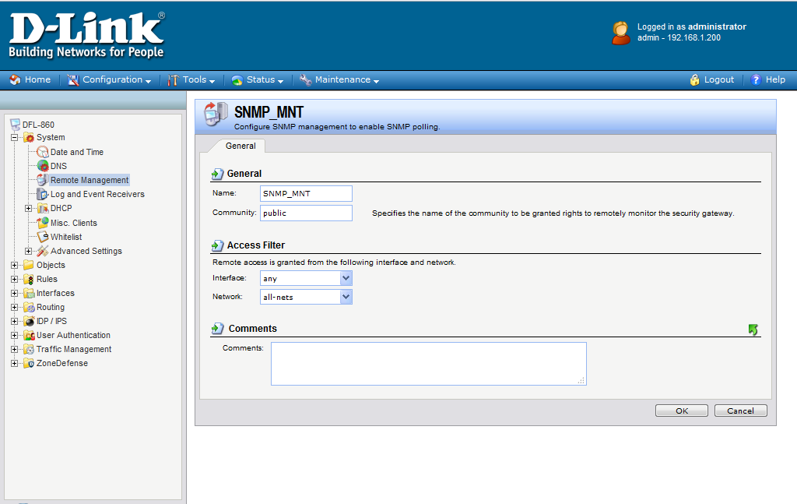

- Install D-View Patch:
On existing D-View 6.0 platform, install patch file (DV-600SB05.exe)

Testing procedure:
