How to change default remote management port

In this document, It will show you how to change HTTP/HTTPS and SSH remote management port for the DFL unit.

Change http/https remote management port.
Step1. Open the Remote Management page and click Modify advanced settings object.
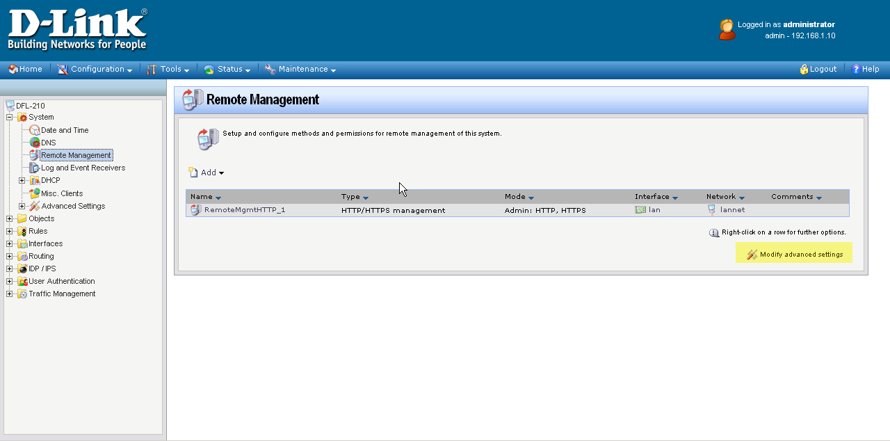
Step2. Change the port number for HTTP/HTTPS server.
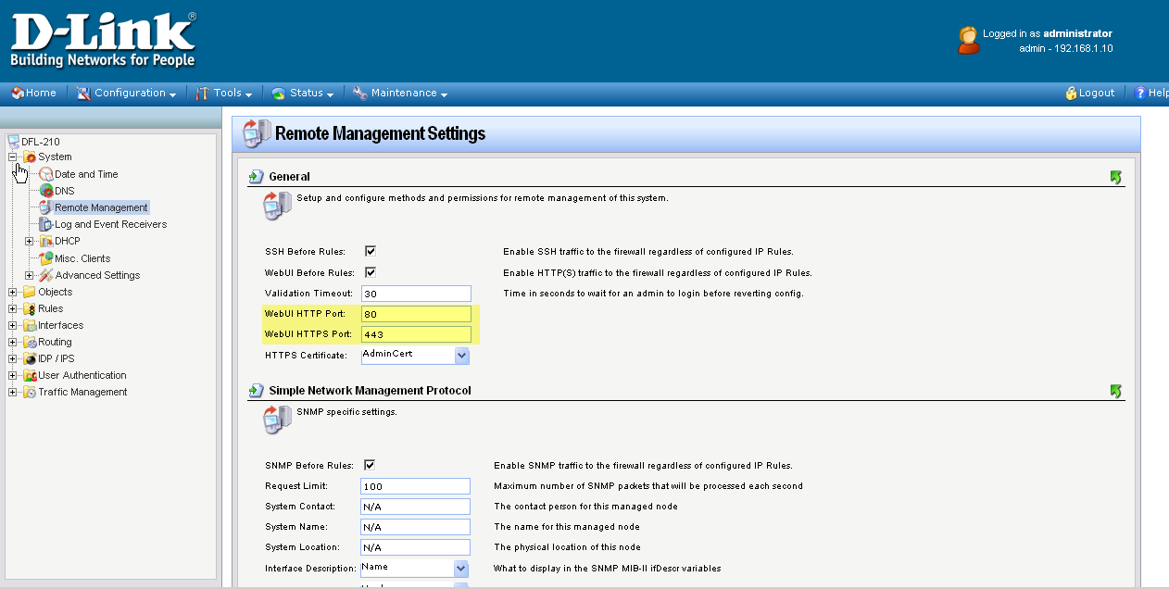
Step3. Click save and active button. And then browser will login with the new management port.
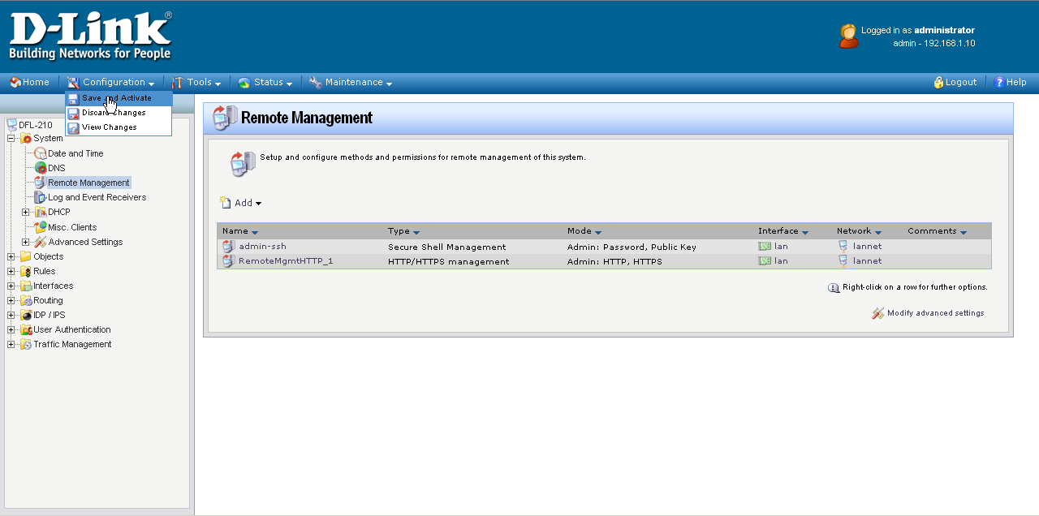
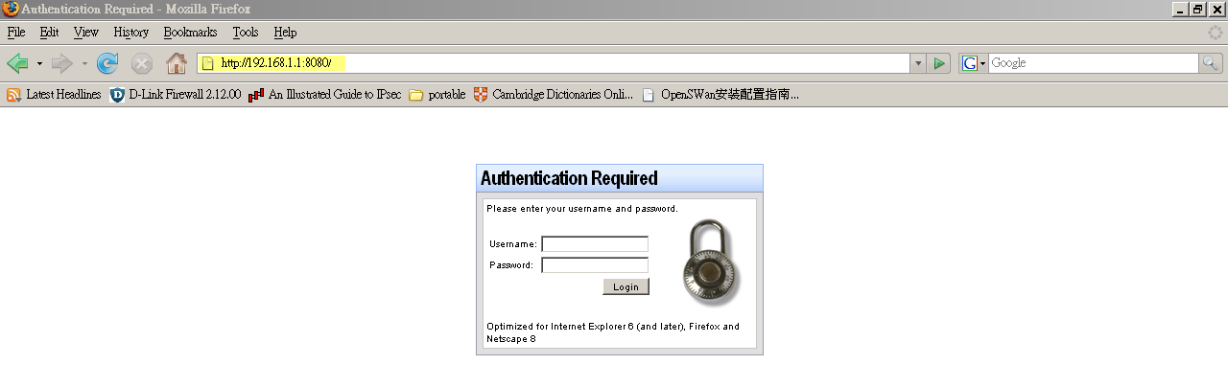

Change SSH remote management port.
Step1.Open the Remote Management page and click the SSH management object.
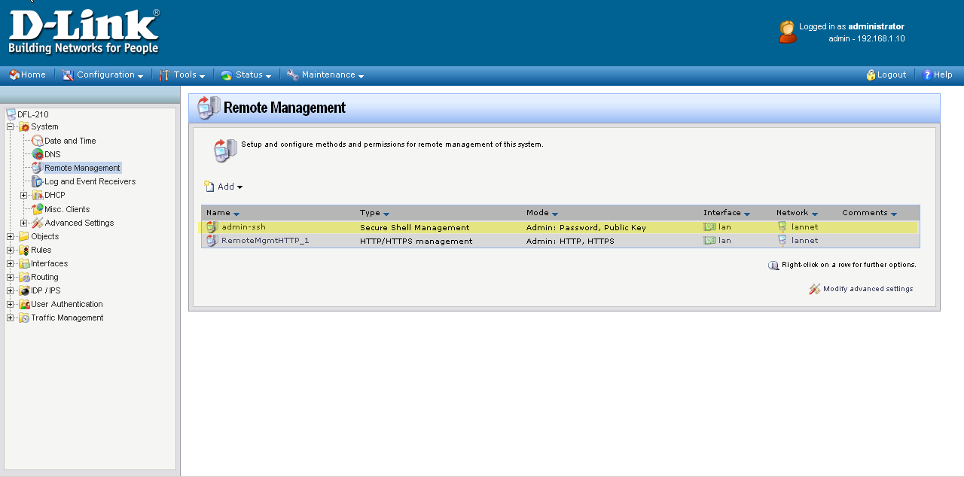
Step2. Change the listening port for the SSH remote management service.
