DFL-870
Date: 2016/11/9

Product Name: | DFL-870 Network Security UTM Firewall
Revision: | A1
Availability: | Nov, 2016
Picture: | 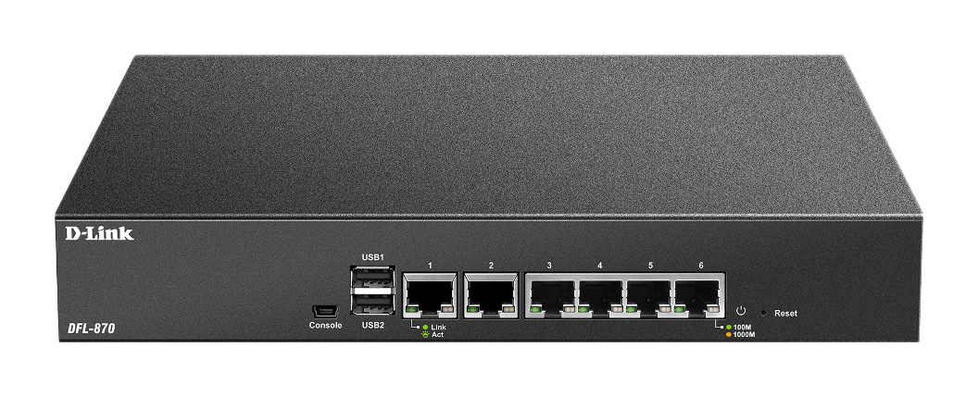
Why Sell This Product: | DFL-870 is D-Link next generation UTM firewall. It is easy-to-deployed and designed for medium business, school, and government organizations that require superior price/performance. This device is a powerful security solution that provided integrated Firewall, Intrusion Prevention System(IPS), Anti-Virus, Load Balance, Fault-Tolerance, Zone-Defense, Web Content Filtering, User Authentication, Denial of Service (DoS) protection as well as Virtual Private Network (VPN) support.  Selling Points  - All-in one UTM firewall/VPN/network security functions.  - Good Firewall/VPN/UTM performance  - D-Link ZoneDefend End-Point security  - 6 configurable gigabit Ethernet ports to provide flexible usage.  - Dual WAN ports provide WAN failover and load balancing  - Link Aggregation
Key Features: | Performance Overview:  6 x 10/100/1000Mbps configurable Ethernet ports  4Gbps plaintext firewall throughput  1Gbps 3DES/AES VPN throughput  450 Mbps IPS/IDP Throughput  600 Mbps Antivirus Throughput  700 Mbps Application Throughput  Concurrent session: 500,000  VPN Tunnel: 200
Technical Details: | Integrated Firewall  - Multiple WAN Ports  - WAN Failover, Outbound Load Balancing  - Link Aggregation  - IEEE 802.1q VLAN  - Granular Bandwidth Management  - D-Link End-to-End Security Solutions (E2ES) Integration with Proactive D-Link ZoneDefense™  Unified Threat Management (UTM)  - Intrusion Prevention System (IPS)  - Antivirus (AV) Protection  - Web Content Filtering (WCF) in HTTP/HTTPS  - Application Control  - E-mail Security  Virtual Private Network (VPN)  - IPSec/PPTP/L2TP/SSL/GRE  - Redundant VPN Gateway  - Hub and Spoke  Advanced Functions  - User Authentication  - Web-based HTTP/HTTPs Authentication (Captive Portal)  - User Identity Awareness  - Active-Passive High Availability  Logging and Monitoring  - Internal log capacity: 500 records  - Log viewer  - Email notification  - Support external log server: syslog server  - Support 8 log receivers  - Real-Time performance monitor  - Event log and alarm  - Sorting/Filtering/Search log messages  - Support SNMP v1, v2c  - SNMP Trap  - SNMP Standard MIB-II and Private MIB  - VPN tunnel monitor
EMI/EMC Report | ☑ FCC No. ☑ CE No. ☑ VCCI No.  ◻ CTR-21 No. ☑ RCM No. ◻ A-Tick No.  ◻ FDA No. ◻ R&TTE No. ` ◻ BSMI No.  ◻ IC No ☑ Others: EAC
Safety | ◻ TUV No. ◻ UL No. ◻ CSA No.  ◻ CB No. ☑ CE ◻ Others:
Packaging Style | ◻Clamshell ◻ White Box ◻Gift Box Bulk ☑Brown Box ◻Others
Packaging Contents: | - DFL-870 x 1  - CAT5 Ethernet cable x 1  - QIG x1  - Power Cord x 1  - Mini-USB to RJ45 Console cable x 1  - Rack Mounting Bracket x2
Country of Origin: | China
UPC Code:
  790069 | 429293 | RFL870A1A....A1G
Units Per Carton: | For USA | For EU | For WW
Units Per Carton: | 4 pcs/Carton | 4 pcs/Carton | 4 pcs/Carton
Cartons Per Pallet: | For USA | For EU | For WW
Cartons Per Pallet: | (Air): pcs  (Sea): pcs  No USA request | (Air): pcs  (Sea): pcs  No EU request | (Air): 27 pcs  (Sea): 36 pcs
Dimensions and Weight: | Box Dimensions:  Device (mm/g):  Carton (cm/kg):  Pallet (cm/kg) for DEU  Pallet (cm/kg) for DI  Intrastat Weight(kg)
  ◻ | 237x168x36mm (Type A) | ◻ | 168x237x53mm (Type A53)
  ◻ | 225x150x75mm (Type B) | ◻ | 150x225x55mm (Type B1)
  ◻ | 269x162x65mm (Type C) | ◻ | 274x208x68mm (Type D)
  ◻ | 208x274x95mm(Type D95) | ◻ | 208x137x95m
  ◻  (T  pe D95 half) | 274x208x118mm (Type D1) | ◻ | 274x208x138mm (Type
  ◻2) | 208x274x190mm (Type D4) | ◻ | 288x245x66mm (Type E)
  ◻ | 245x285x82mm(Type E1) | ◻ | 245x285x87mm(Type E2)
  ◻ | 256x356x97mm (Type F) | ◻ | 137x208x36mm (Type G)
  ◻ | 208x250x68mm (Type H) | ◻ | 253x27x24
  ☑mm (Type I) | Others: 396 x 273 x 80 mm
  Device Length | Device Width | Device Height | Device Weight
  278 mm | 183 mm | 44 mm | 1700
  Carton Length | Carton Width | Carton Height | Carton Gross Weight
  35.0 | 29.2 | 41.8 | 12.1 kg
  Carton per Air Pallet | Air Pallet PCS | Air Pallet Length | Air Pallet Width | Air Pallet Height | Air Pallet Weight
  27 | 108 | 110 | 120 | 140 | 325.0000
  Carton per Sea Pallet | Sea Pallet PCS | Sea Pallet Length | Sea Pallet Width | Sea Pallet Height | Sea Pallet Weight
  36 | 144 | 110 | 120 | 140 | 433.9000
  Carton per Air Pallet | Air Pallet PCS | Air Pallet Length | Air Pallet Width | Air Pallet Height | Air Pallet Weight
  27 | 108 | 110 | 120 | 140 | 325.0000
  Carton per Sea Pallet | Sea Pallet PCS | Sea Pallet Length | Sea Pallet Width | Sea Pallet Height | Sea Pallet Weight
  36 | 144 | 110 | 120 | 140 | 433.9000
  Full Package Weight | Net Mass Weight  (WEEE Weight) | Packaging Weight- Paper | Packaging Weight- Plastic | Packaging Weight- Mixed | SubTotal Weight  Paper+Plastic+Mixed
  2.6700 | 2.1078 | 0.5500 | 0.0120 | 0.0002 | 0.5622

