How do I upgrade the firmware for the DFL-M510?
Step 1: Log into the DFL-M510.
Step 2: Click on Tools and select Upgrade.
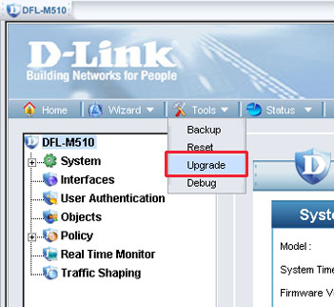
Step 3: Click on Browse and locate the firmware file (?image?extension), then click on Upload.
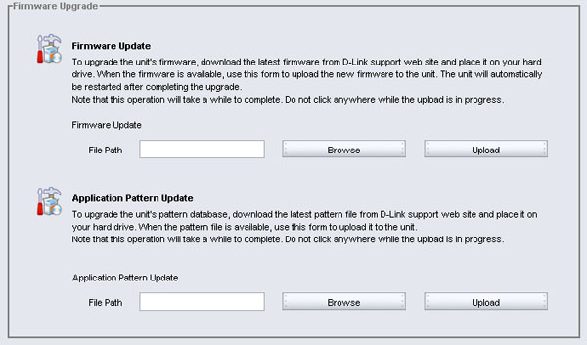
Step 4: Please wait while the firmware is being loaded. Do not interrupt the loading process. Doing so may damage the unit.
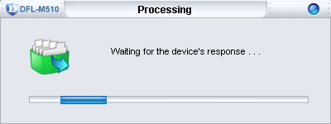
Step 5: Click OK when prompted.
