How to create web content filter on DFL-M510, you can follow below procedure to create it step-by-step:
Step1 Under Policy--->Keyword filter---> input the specific keyword value you want to filter.
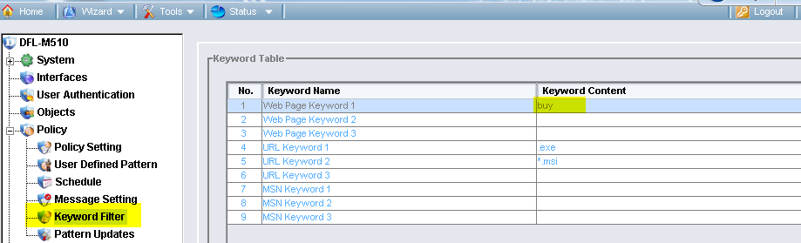
Step2. Under Policy--->Policy settings---> add new template and named it.
Step3. In the template rules, enable the function of "Web Page Keyword 1" and select the action to block.
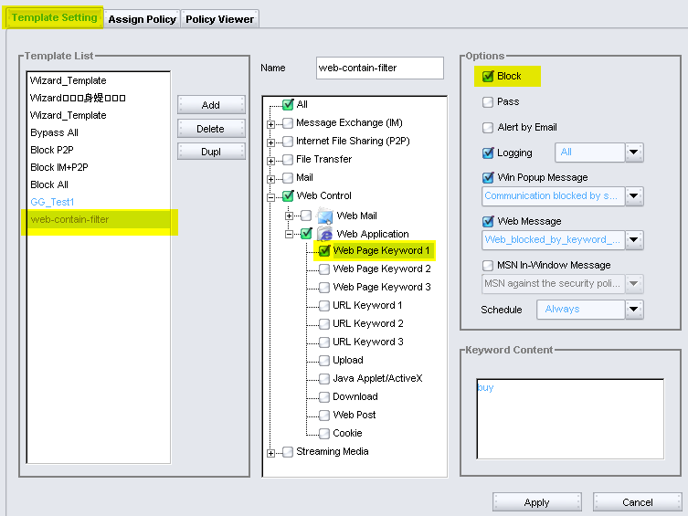
Step4. Under the tag of Assign Policy, select a host or a group for appling the rule set.
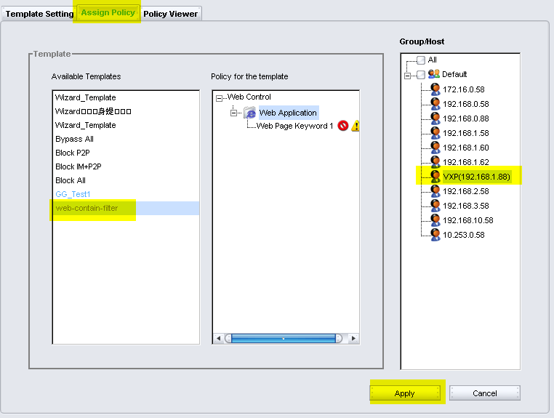
Step5 Based on the logs of DFL-M510, you can find the specific host has already been blocked by our policy of web content filter:
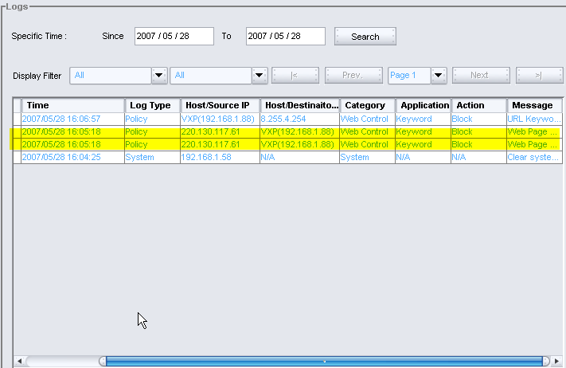
End of document

