1. Open Network Preferences:
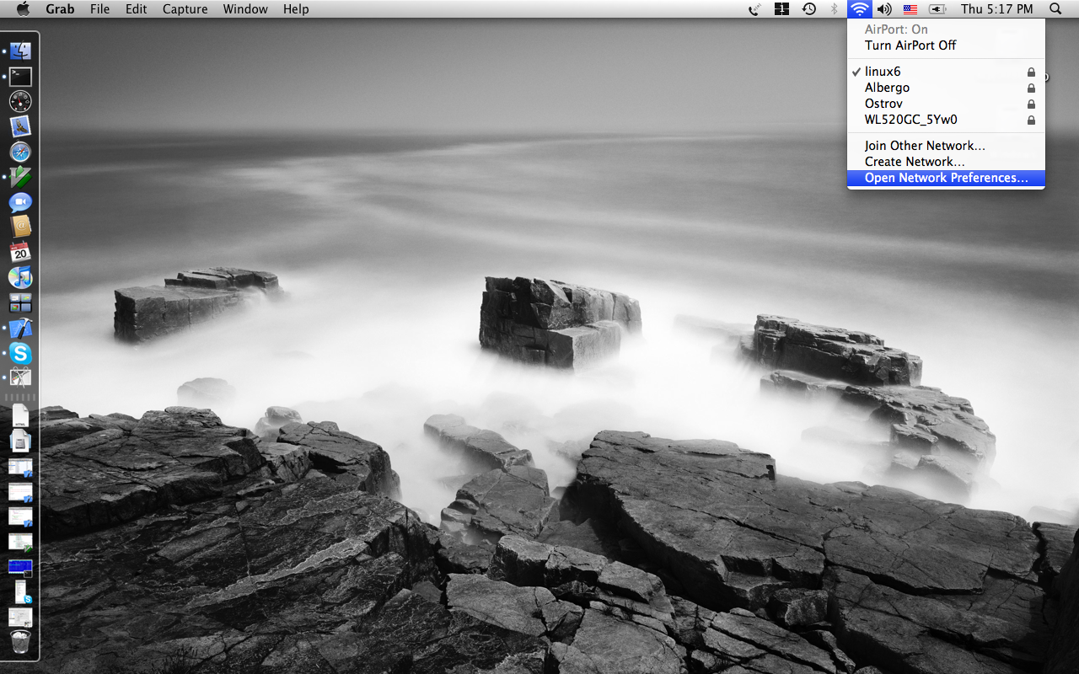

2. Select “USB EtherNet”:
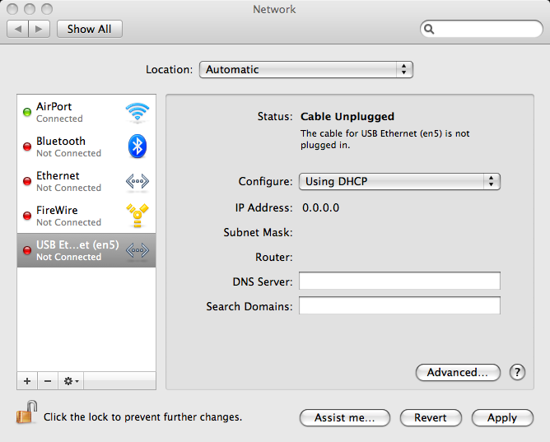

3. Activate Configuration listbox:
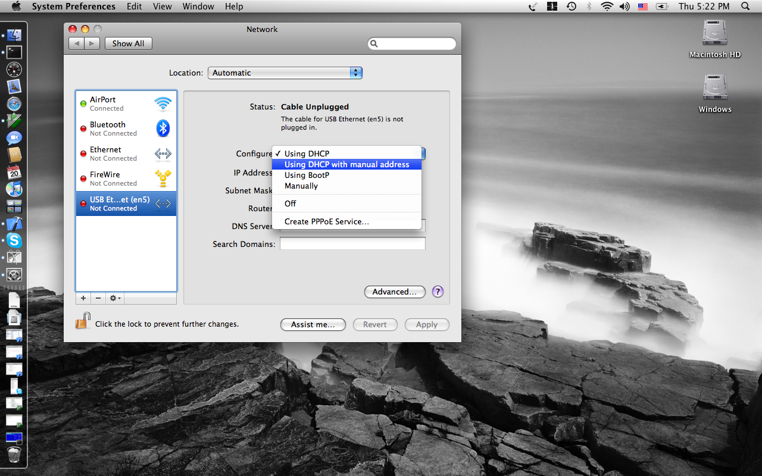

4. From there you can choose between various IP setting methods. You are
interested mostly in "Using DHCP" --- automatic IP setting and "Manually" ---
for manual IP information enter.
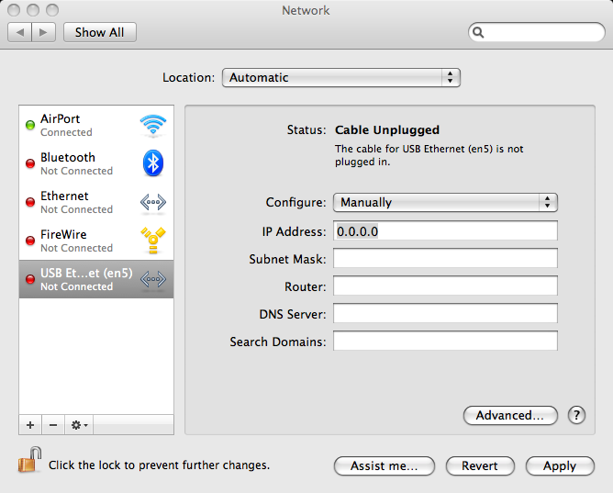

Press “Apply” after finishing configuration.

