Topology
IPsec over dynamic IP
 PC2:192.168.20.10/24

LAN1 ip:192.168.20.1/24
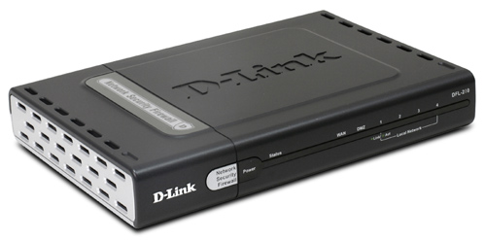wan:dynamic ip address
IPsec vpn

Internet
IPsec VPN

Wan2 GW:61.218.67.121
Wan2:61.218.67.126/28 wan1: dynamic ip address
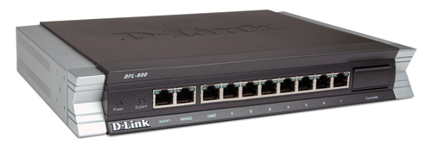LAN1 IP:192.168.1.1/24

PC1:192.168.1.10/24
Configure in DFL-210
(1)Go to objects->authentication objects.Create new object.
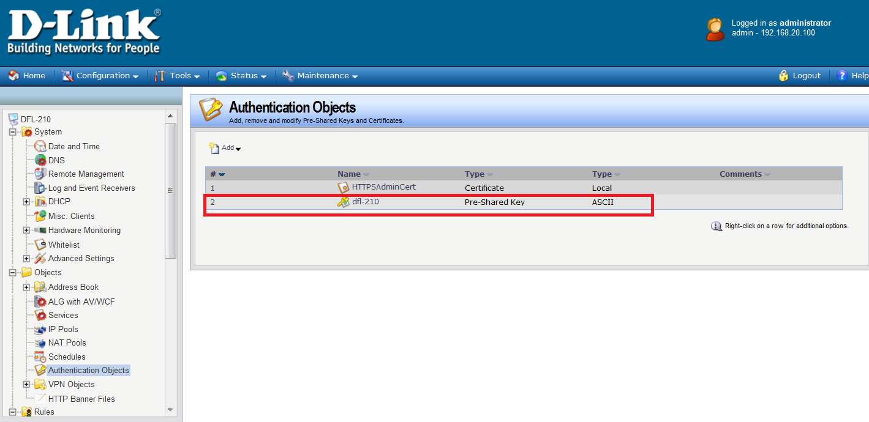
(2)go to object”dfl-210”,type name and shared secret.
The password I used “dlink”.
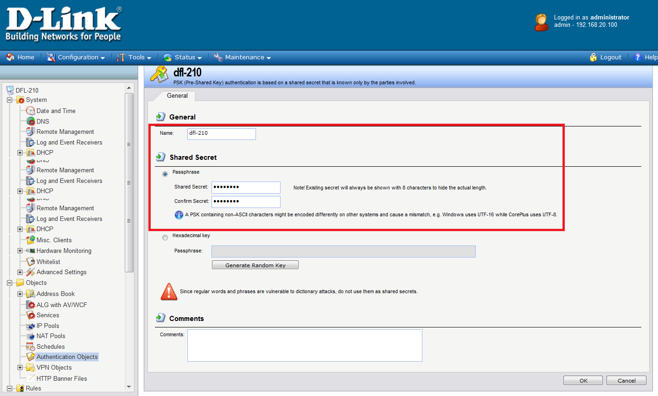

(3)Go to IPsec add a new object”test”.Create a new tunnel.
Local net ”lannet”
Remote Net “192.168.1.0/24”
Remote Endpoint “61.218.67.126”
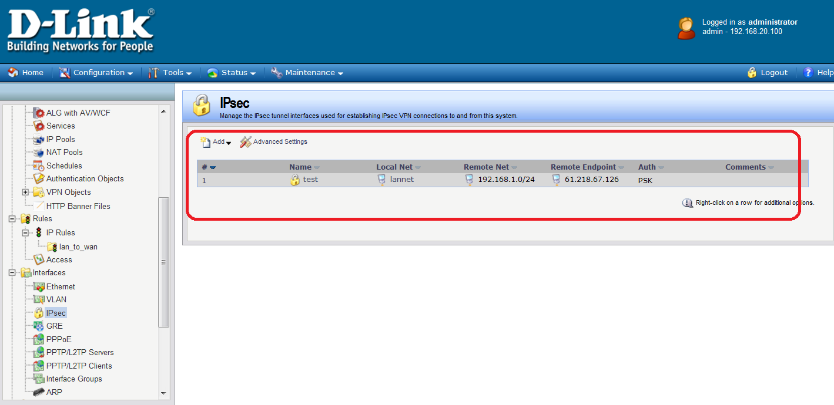
(4) Go to new object “test”->”authentication”.Choose the correct Pre-Shared Key.
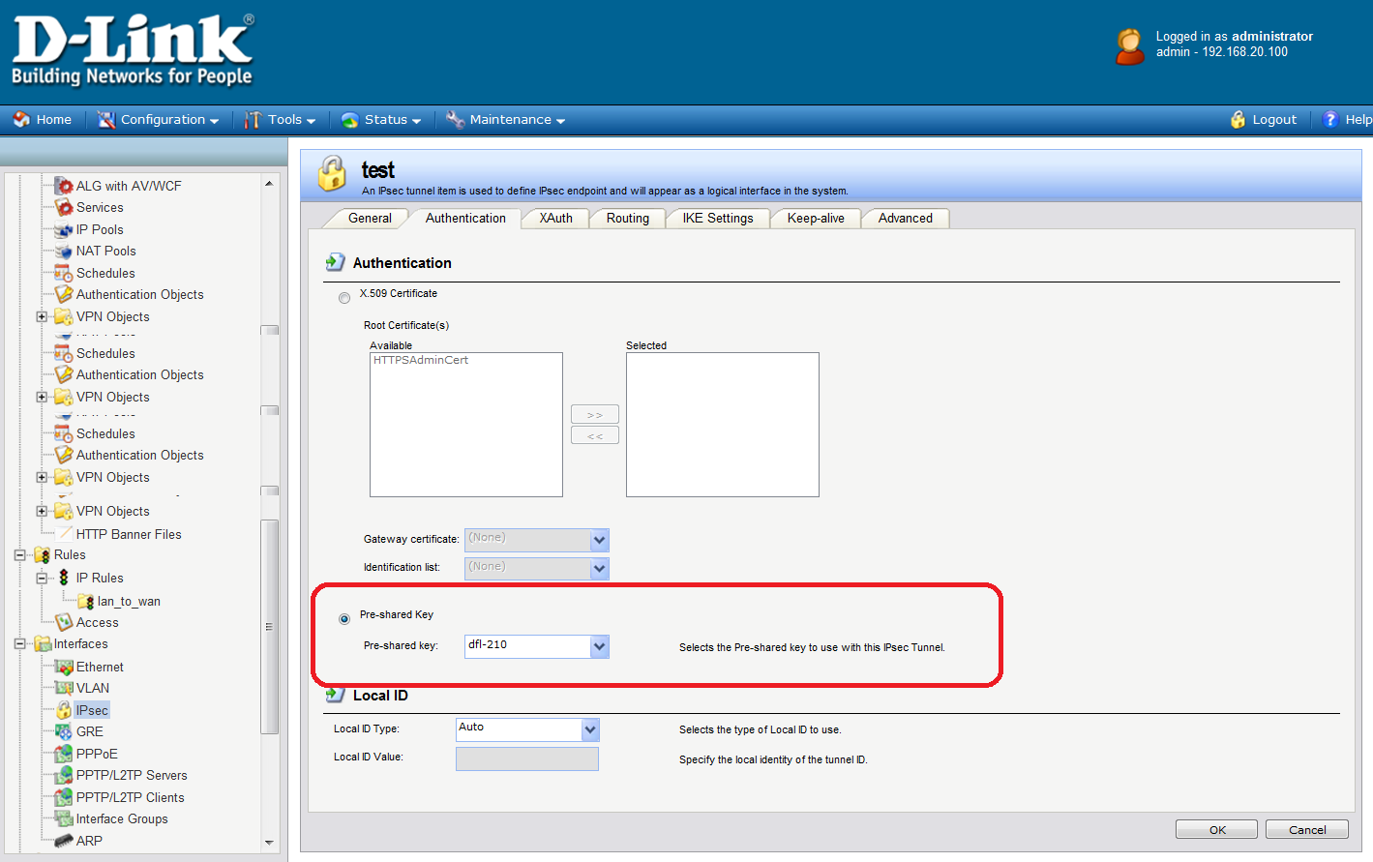

(5) Go to IP Rules.Add two new ip rules.”allow-go-vpn” “allow-from-vpn”
allow-go-vpn: action->allow or nat, src if->lan , src net->lannet ,
dest if->test dest net->192.168.1.0/24 service->all_services
allow-from-vpn: action->allow or nat , src if->test , src net->all-net ,
dest if->lan dest net->lannet service->all-services
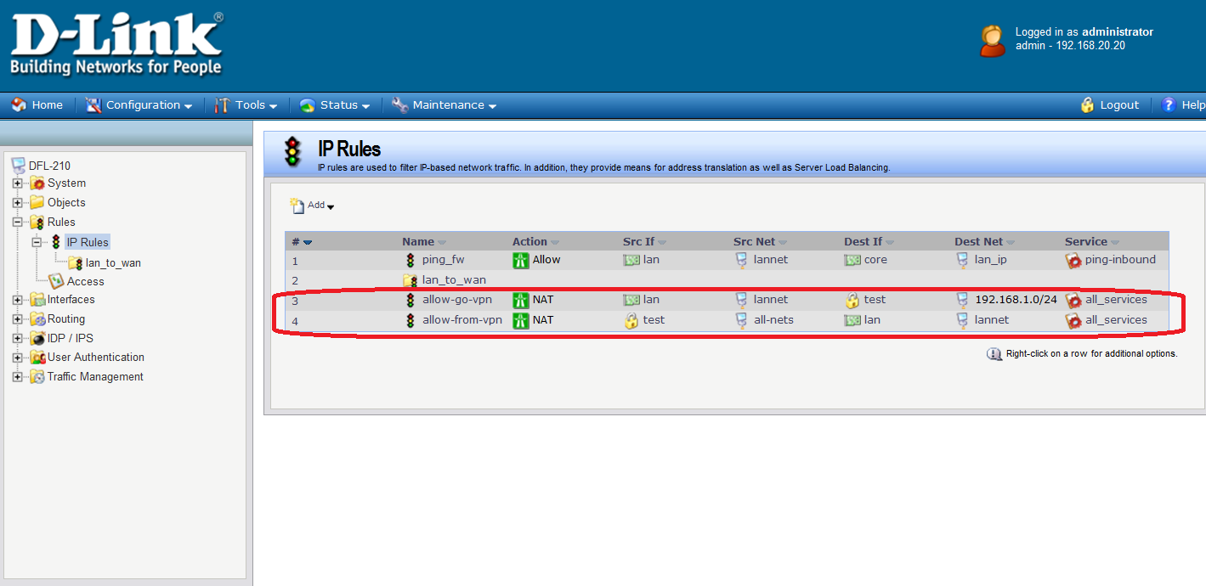

Configure in DFL-800
(1) Go to address book.Add a new address “remote-net”.
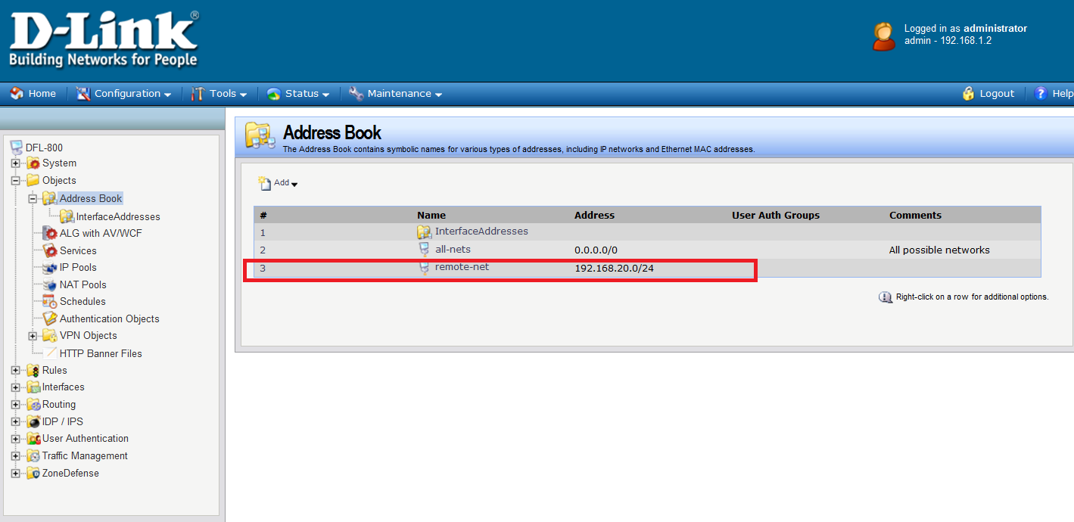
(2)Change WAN2 ip address,network and default gateway.
Wan2:61.218.67.126/28 GW:61.218.67.121/28
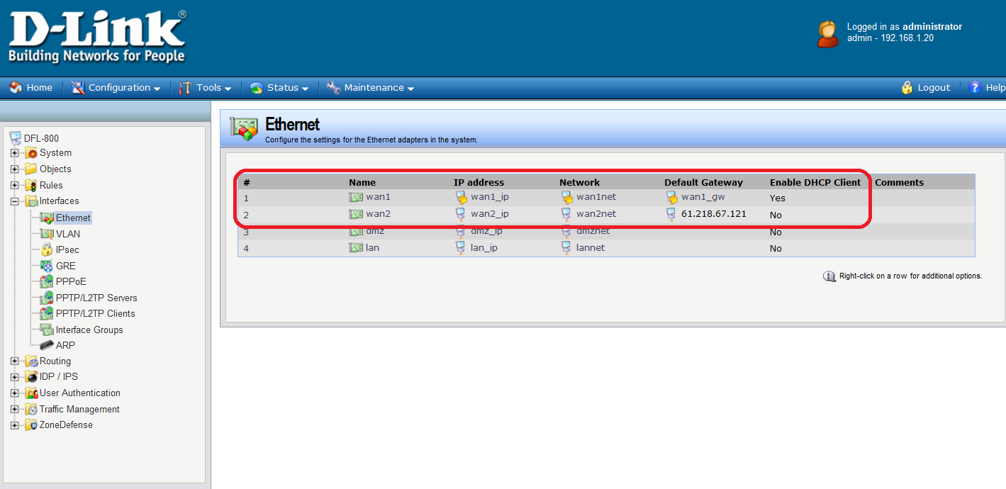

(3) Go to interfaces -> IPsec. Add a new tunnel”test”.
Remote Endpoint does not need choose.Because the Remote endpoint is dynamic IP address.
IKE Algorithms:medium
IPsec Algorithms:medium
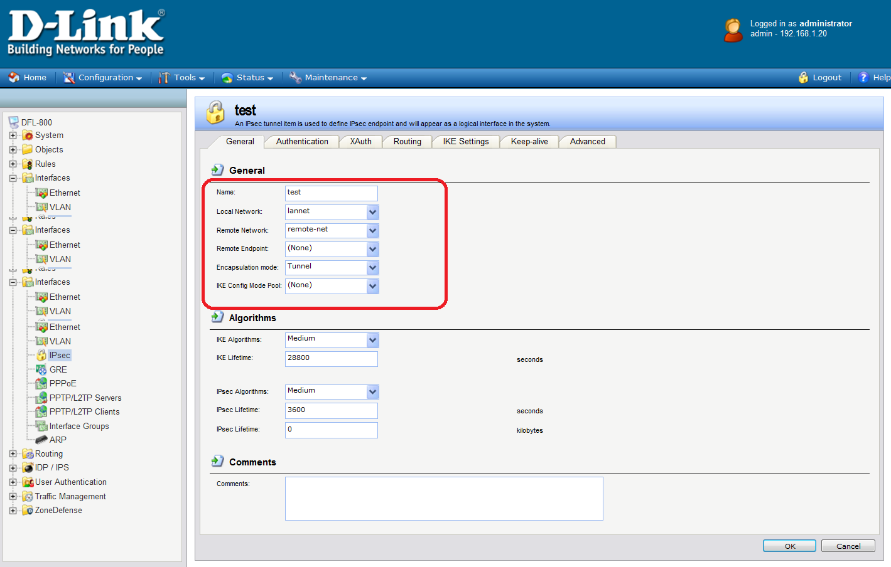

(4) Go to new object “test”-> “authentication”.Choose the correct Pre-Shared Key.
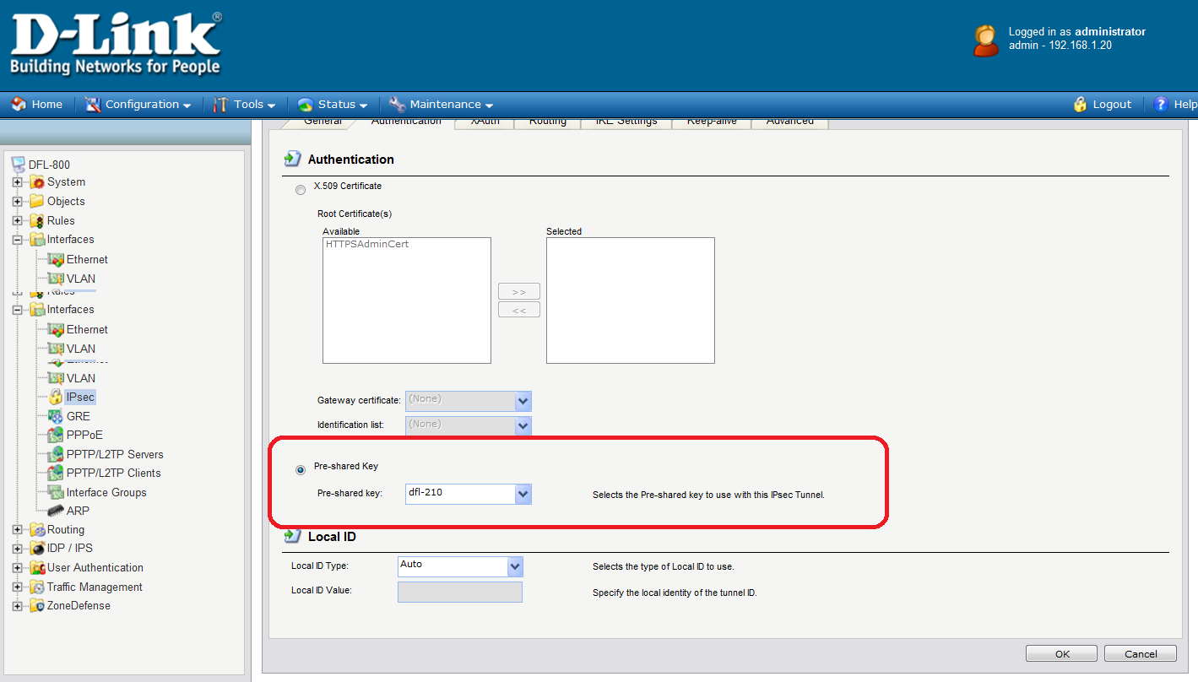
(5) Go to new object “test”-> “Routing”.Choose the “Dynamiclly add route”item.
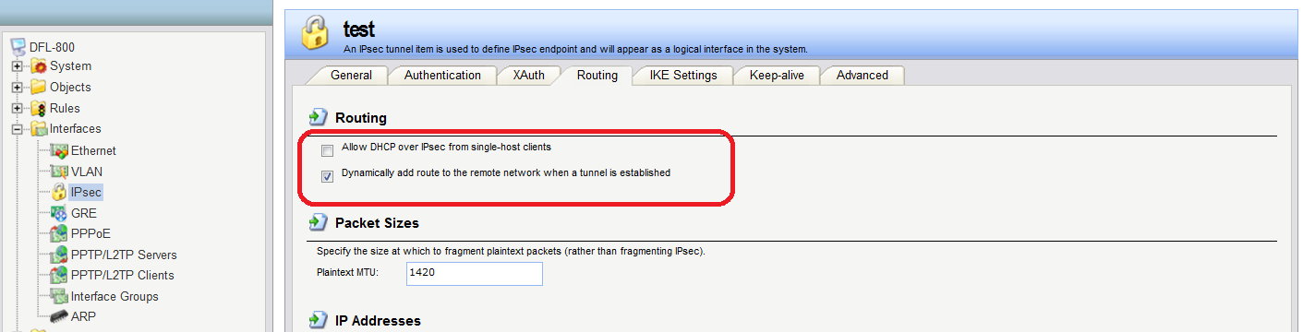

(6) Go to new object “test”-> “Advanced”. Do not choose this button.
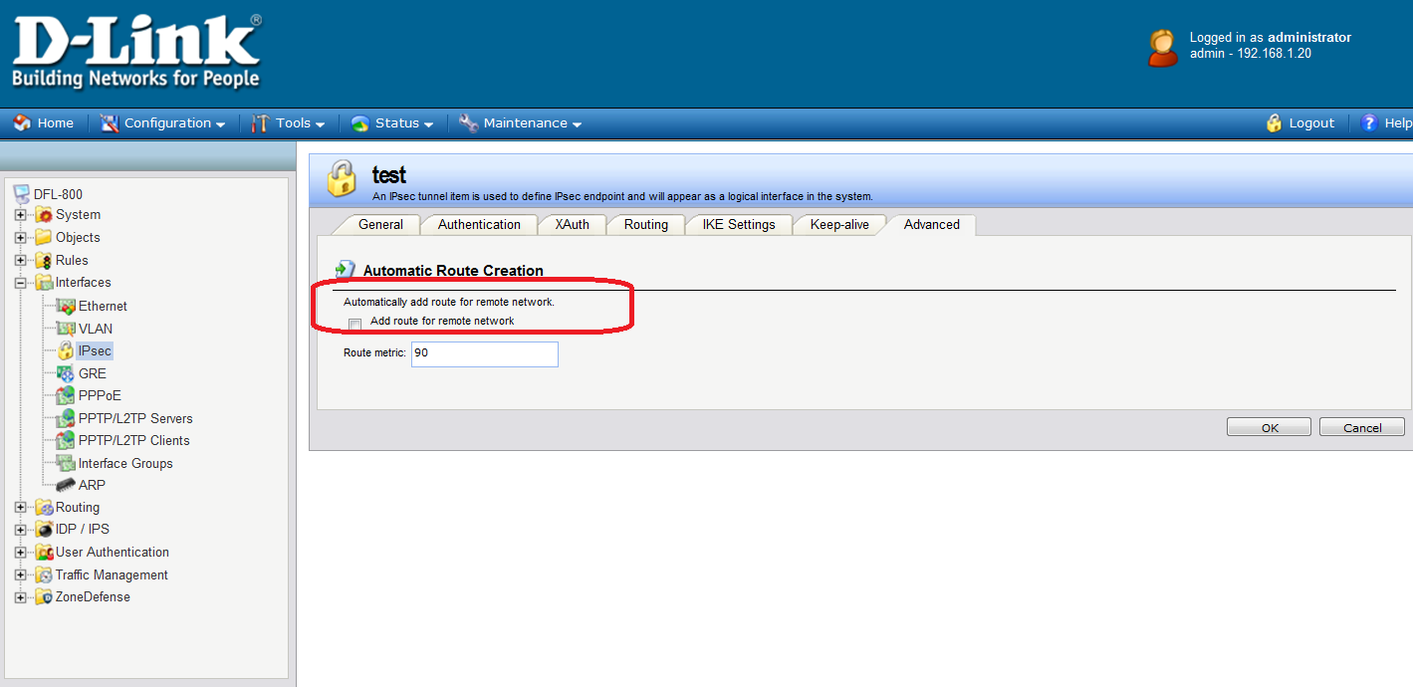

(7)Go to IP rules.Add two new rules “allow-go-vpn” and “allow-from-vpn”.
allow-go-vpn: action->allow or nat, src if->lan , src net->lannet ,
dest if->test dest net->remote-net service->all_services
allow-from-vpn: action->allow or nat , src if->test , src net->all-net ,
dest if->lan dest net->lannet service->all-services

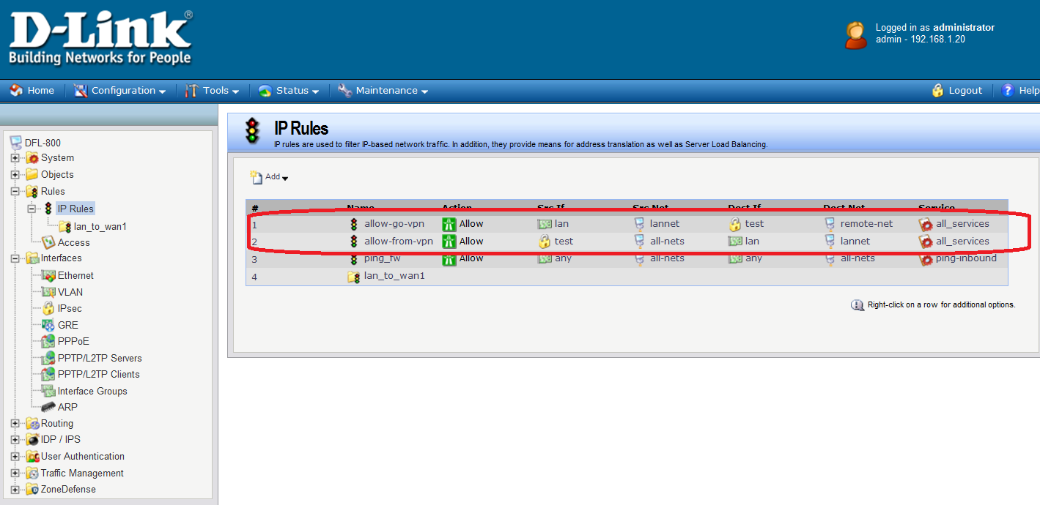
(8)
Use pc2 ping pc1
Use CLI:ipsecstats
