LAN 1:192.168.2.0/24

DFL-800
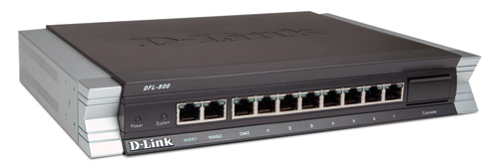WAN1:3.3.3.2/24

IPsec Tunnel

DFL-860 WAN1:3.3.3.1/24
LAN:192.168.1.1/24

OSPF area 1 ; LAN 2:192.168.1.0/24

LAN: 192.168.1.2/24
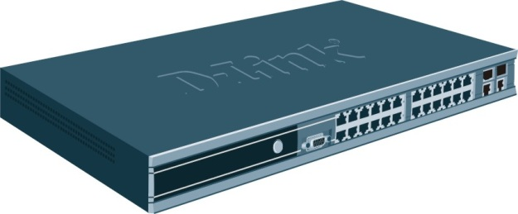 L3 SWITCH
LAN: 10.10.1.1/24

OSPF area 0 BACKBONE area
LAN3:10.10.1.0/24
LAN:10.10.1.2/24
L3 SWITCH

OSPF
Add new ospf object
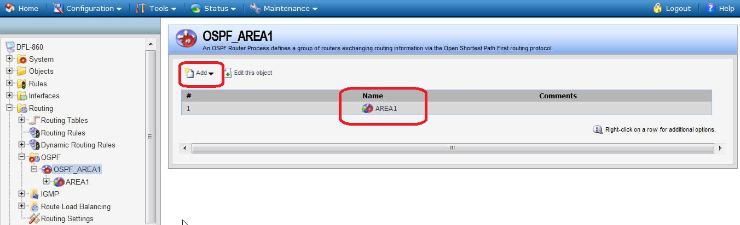
Click the edit this object item
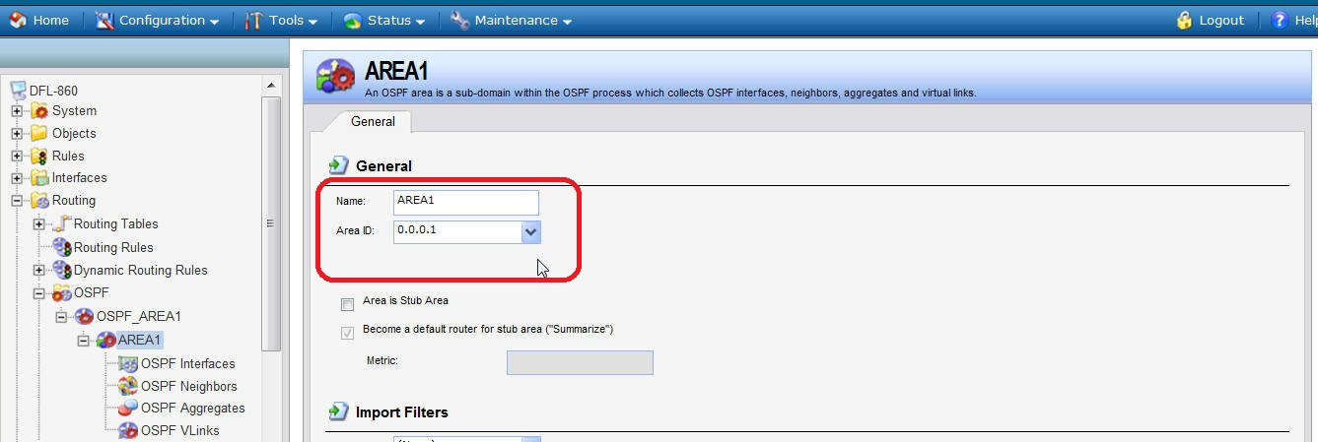

Touch OSPF interface button
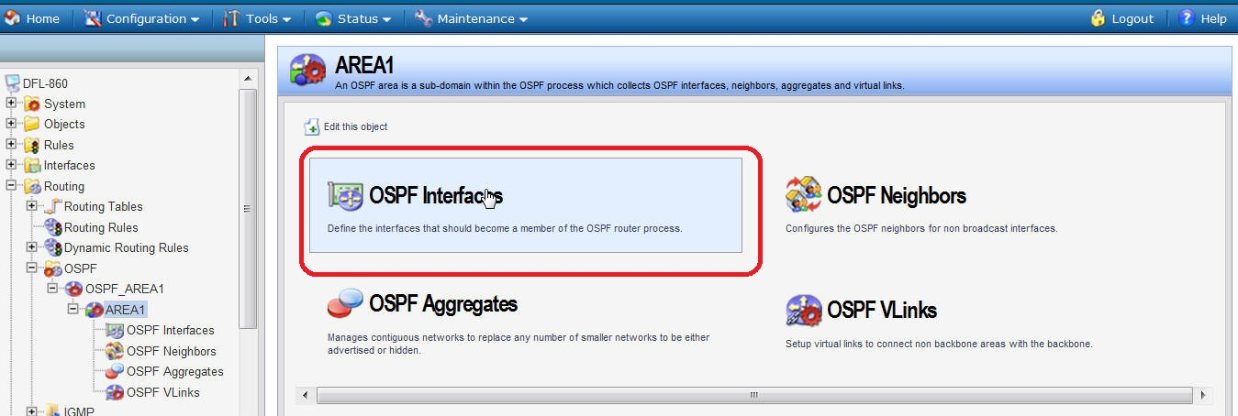

In the OSPF Interfaces, add the “lan” into the list.
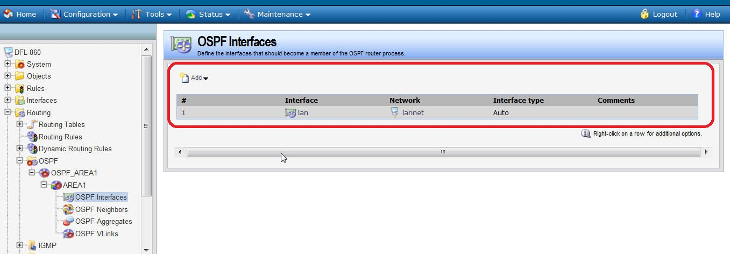

For the LAN detail parameters as following:
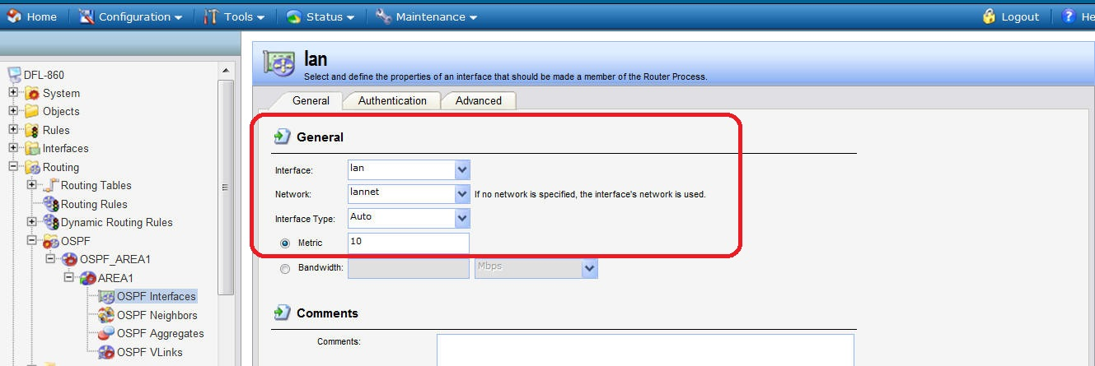

Create two “Dynamic Routing Rules”: “OSPF_to_main” and “main_to_ospf” respectively.
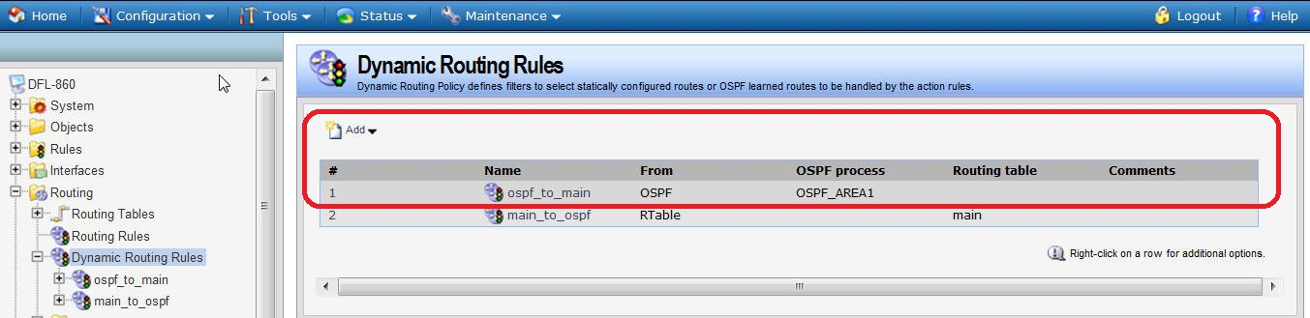

(1)In the object of “ospf_to_main”:
Go into the Routing actions
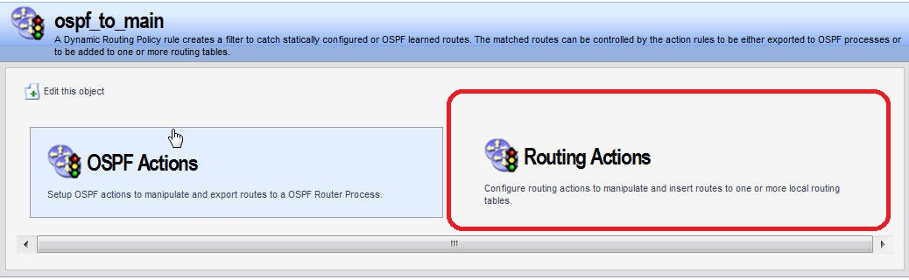

OSPF action is mapped to main_to_ospf object
Move the main from available to selected
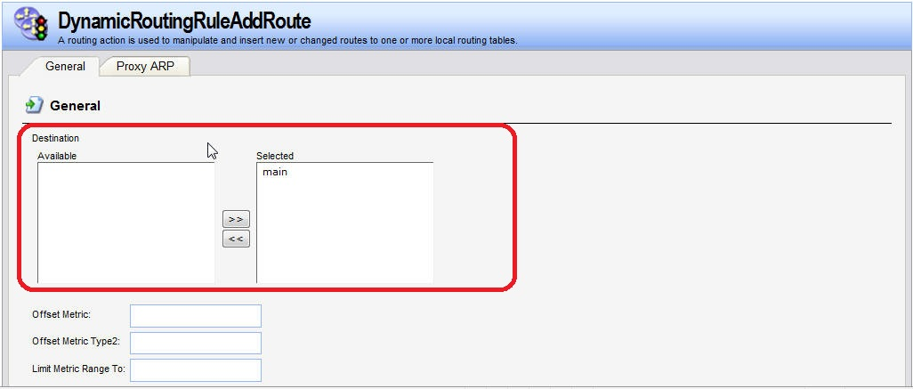
(2) In the object of “ospf_to_main”:
Go into the OSPF actions
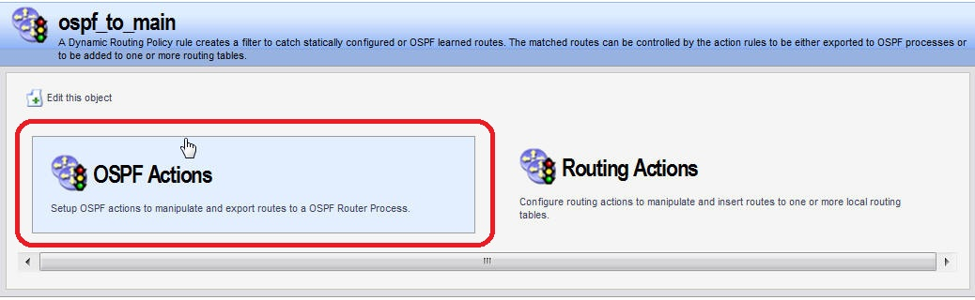
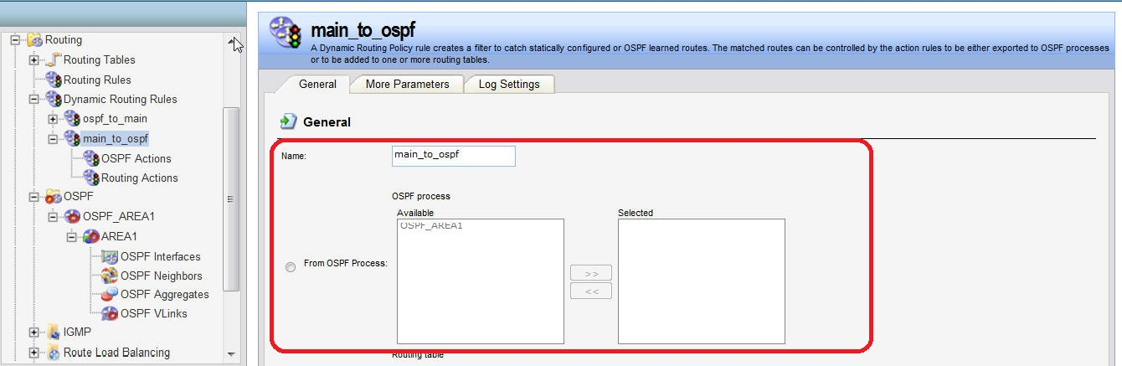
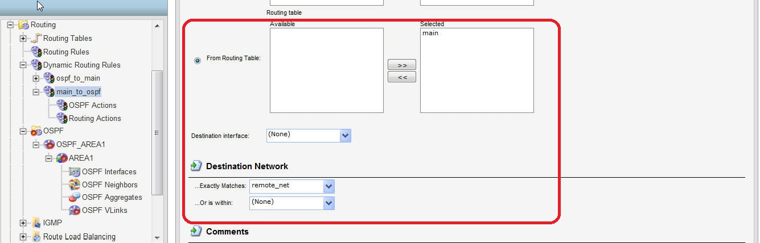
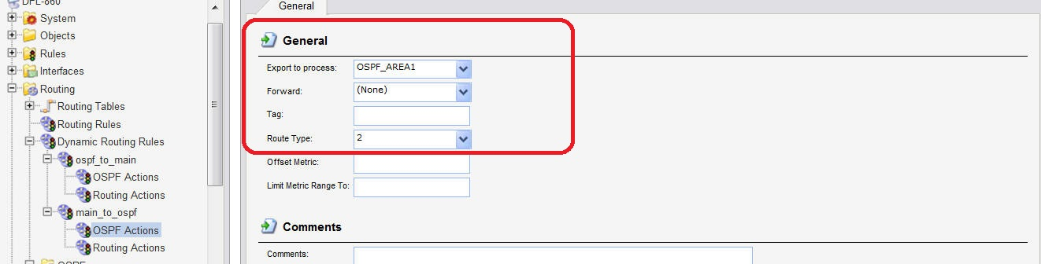

DFL-860 IPsec
Create pre-shard key
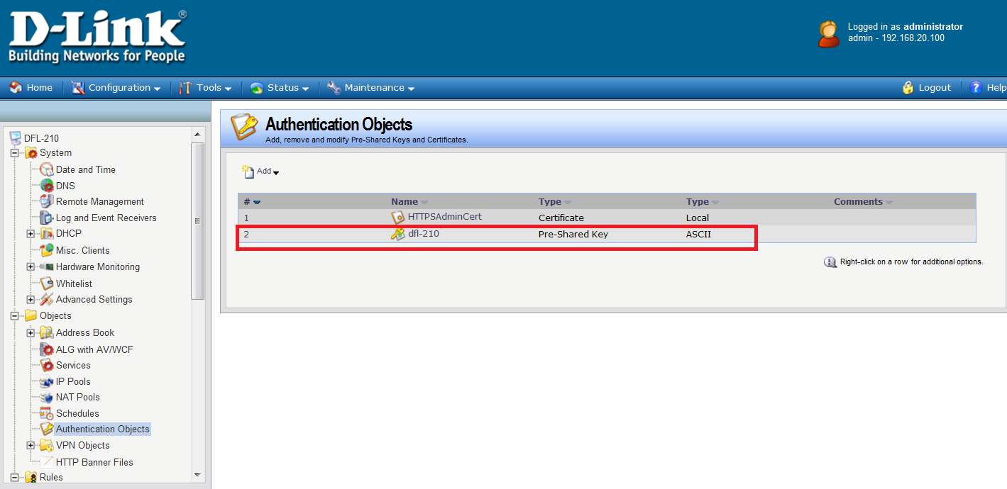
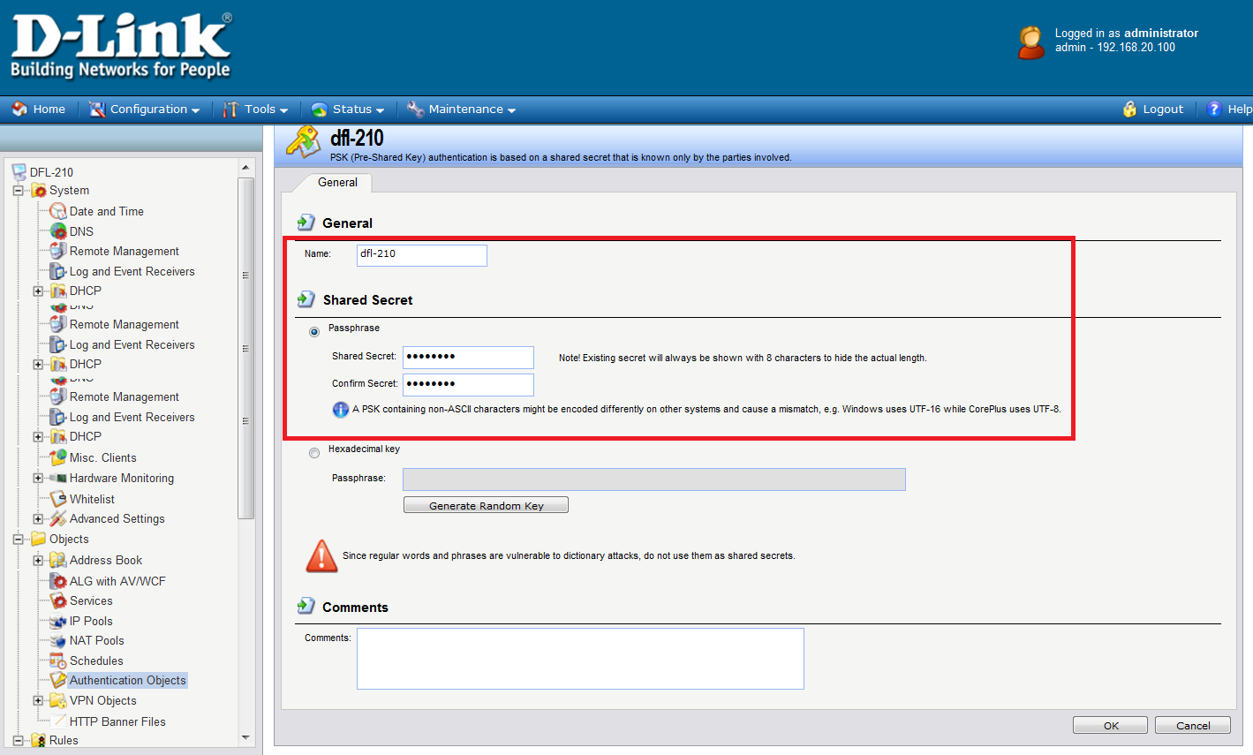
Go to address book create IP object. Remote network
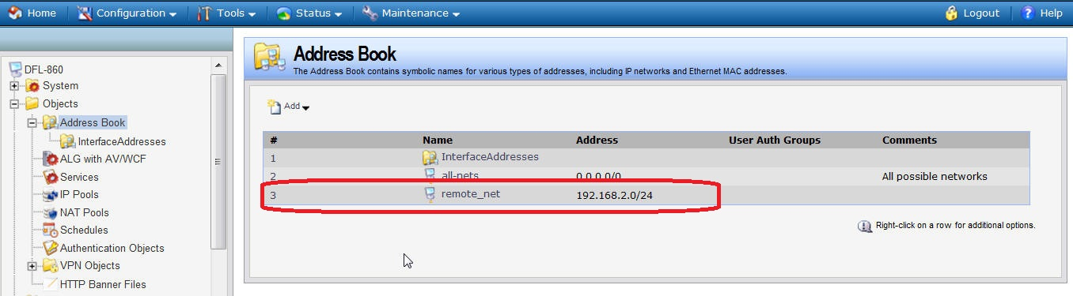

Go to IPsec. Add a new IPsec tunnel.
Choose the correct item.
local network to lannet.
Remote network to remote_net
Remote endpoint to 3.3.3.2/24
Encapsulation mode to tunnel
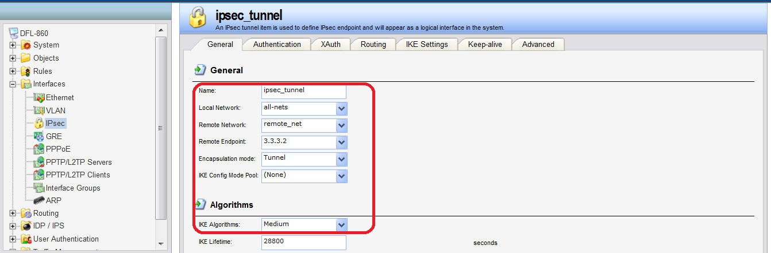

You will see IPsec tunnel route in the main.
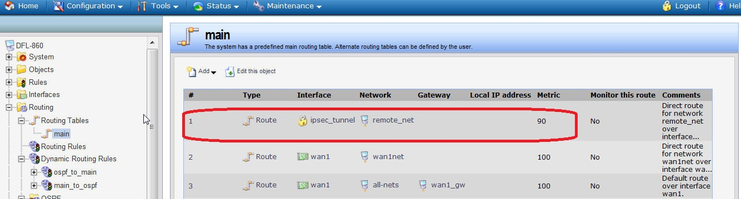

Set up two IP rules for the tunnel:
An allow rule for outbound traffic that has the previously defined ipsec_tunnel object
As the Destination interface.The Destination network is the remote network remote_net.
An allow rule for inbound traffic that has the previously defined ipsec_tunnel object
As the Source interface.The Source network is the remote network remote_net.
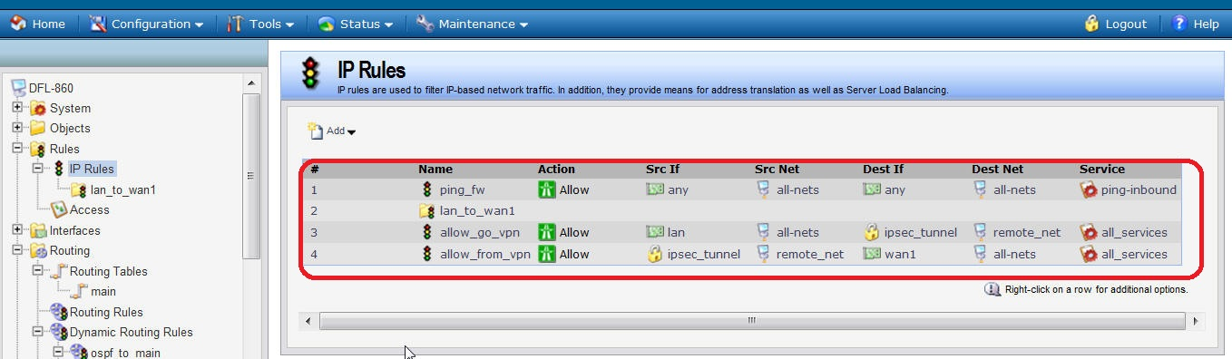

Finally you can use CLI:ipsecstats to check the IPsec tunnel!!

